Weighted Smoothing Filters
Code:
import cv2
import numpy as np
import matplotlib.pyplot as plt
image = cv2.imread('yang.jpg', cv2.IMREAD_COLOR)
image_rgb = cv2.cvtColor(image, cv2.COLOR_BGR2RGB)
kernel = np.array([[1, 2, 1], [2, 4, 2], [1, 2, 1]], dtype=np.float32) / 16
weighted_smoothed_image = cv2.filter2D(image, -1, kernel)
smoothed_rgb = cv2.cvtColor(weighted_smoothed_image, cv2.COLOR_BGR2RGB)
plt.figure(figsize=(12, 6))
plt.subplot(1, 2, 1)
plt.title("Original Image")
plt.imshow(image_rgb)
plt.axis('off')
plt.subplot(1, 2, 2)
plt.title("Weighted Smoothed Image")
plt.imshow(smoothed_rgb)
plt.axis('off')
plt.show()
Code Explanation:
- Loading the Image:
  - The image is loaded using cv2.imread('yang.jpg', cv2.IMREAD_COLOR), which reads the image in BGR format.
  - cv2.cvtColor(image, cv2.COLOR_BGR2RGB) converts the image to RGB format for correct color display in Matplotlib.
- Defining the Weighted Kernel:
  - The kernel np.array([[1, 2, 1], [2, 4, 2], [1, 2, 1]], dtype=np.float32) / 16 is a weighted smoothing kernel (a type of Gaussian kernel).
  - The weights in the kernel are higher at the center, allowing for stronger smoothing around the center pixel.
- Applying the Weighted Filter:
  - cv2.filter2D(image, -1, kernel) convolves the image with the weighted kernel. The -1 indicates the output image will have the same depth as the input.
- Visualization:
  - The original and smoothed images are displayed side by side using matplotlib.pyplot for comparison.
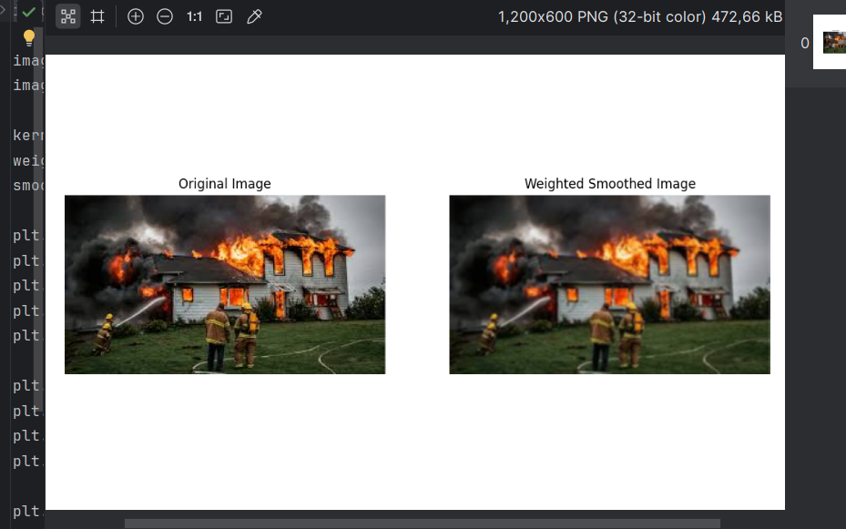
Output:

Report
Objective
To apply a Weighted Smoothing Filter to the "yang.jpg" image to reduce noise and create a smoother appearance while retaining key image details.
Methodology
- A 3×33 \times 33×3 weighted kernel was used. The kernel emphasizes the center pixel (weight = 4/16) while considering neighboring pixels with lower weights.
- The convolution operation was performed using OpenCV's filter2D function, which applies the kernel to the entire image.
Results
- Original Image:
  - The original "yang.jpg" image showed minor noise and sharp transitions between pixel values.
- Weighted Smoothed Image:
  - The smoothed image exhibited reduced noise and a softened appearance, particularly in regions with gradual intensity changes.
  - Edges were preserved better compared to unweighted averaging filters due to the weighted kernel's design.
Advantages of Weighted Smoothing:
- Preserves edges better than standard averaging filters.
- Reduces noise effectively without over-smoothing fine details.
- Computationally efficient for small kernel sizes.
Applications:
- Preprocessing for edge detection or segmentation.
- Enhancing image quality in photography and computer vision tasks.

